NEW !!

Symbol | Parameter | Conditions | Min | Typ | Max | Unit
Vcc | Operating supply voltage |  | 1.5 | - | 12 | V
Icc | Peak Current |  | - | 5 | 9 | mA
Vin | Input High Voltage | IData=100Ua (High) | Vcc-0.5 | - | Vcc | V
Vii | Input Low Voltage | IData=0Ua (Low) | - | - | 0.3 | V
Fo | Absolute Frequency |  | 314.8 | 315 | 315.2 | MHz
△FO | Relative To 433.92MHz |  |  | +/-150 | +/-200 | KHz
Po | RF Out Power Into 50Ω |  | -3 | 0 | +2 | dBm
 | Modulation Bandwidth | External Encoding | - | 5 | - | KHz
Tr | Modulation Rise Time | External Encoding | - | - | 100 | uS
Tf | Modulation Fall Time | External Encoding | - | - | 100 | uS
Notes : ( Case Temperature = +25C+/-2C Test Load Impedance = 50 Ω )

Application Circuit I:
Typical Keychain Transmitter using HCS 300 or PIC16C621, a rolling code Encoder from
Microchip Technology Inc.
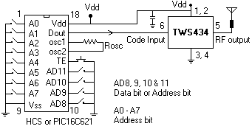Symbol | Parameter |  | Conditions |  | Min | Typ |  | Max
Vcc | Operating supply voltage |  |  |  | 4.9 | 5 |  | 5.1
ITot | Operating supply voltage |  |  |  | - | 4.5 |  | -
V Data | Data Out |  | Data = +200 uA ( High )I |  | Vcc-0.5 | - |  | Vcc |  | V
V Data |  |  | I Data = -10 uA ( Low ) |  | - | - |  | 0.3 |  | V

Electrical Characteristics
Characteristics |  | SYM |  | Min | Typ |  | Max |  | Unit
Operation Radio Frequency |  | FC |  | 300 - 434 |  |  |  |  | MHz
Sensitivity |  | Pref |  |  |  |  | -106 |  | dBm
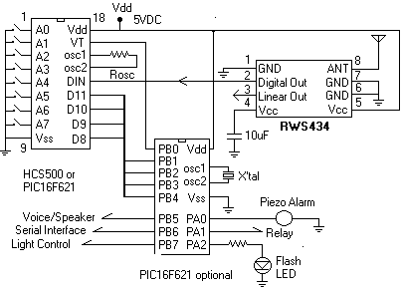Channel Width |  |  |  | +-500 |  |  |  |  | KHz
Noise equivalent BW |  | NEB |  |  | 5 |  | 4 |  | KHz
Baseboard data rate |  |  |  |  |  |  | 3 |  | Kb/s

